This equipment certificate complies with the requirements of Emirates International Accreditation Centre for inspection bodies working in the field of Lifting Equipment and Lifting Accessories (EIAC-RQ-IB-002), reference standard
BS EN 818-1:1996+A1:2008, BS EN 818-2: 1996 +A1:2008, BS EN 818-3: 1999 +A1:2008, BS EN 818-4:1996+A1:2008,
BS EN 818-5:1999+A1:2008, BS EN 818-6:2000+A1:2008, BS EN 818-7:2002+A1:2008, and Manufacturer’s Specification
Owner Name: Mr Dhillon, Mr. Mani
Office Address: P.O. Box: 11072
Dubai
United Arab Emirates
Equipment Location: Gold 2 Project

INSPECTION DETAILS
Date of Inspection: | 18-07-2025 |  | Expiry Date: |  | FAILED
Inspection Type: PERIODIC
Previous Inspection Report: | cb |  | Last Proof Load Test: |  | 18-07-2025
Test Method | CSI-07 |  | Calibrated Test Equipment: |  | r
Test Method |  |  | Client Test Equipment: |  | f
EQUIPMENT INSPECTION
EQUIPMENT ID & SERIAL NO.: |  | EQUIPMENT DESCRIPTION | QTY | SAFE WORKING LOAD |  | TEST LOAD APPLIED | TYPE OF TEST & RESULT
r |  | Manufacturer: t  Chain Diameter: g  Chain Length: f  Number of Legs: g  Grade: g | t | t |  | t | g


This is to certify that the above item/s described in this certificate was tested and particulars are correct.

CSSC has inventoried, inspected, verified and tested above mentioned equipment in accordance with the reference standards cited herein and consistent with CSSC policies and procedure. We certify this above mentioned equipment is UNSAFE TO USE, condition prevails at the time of this inspection.

All the information obtained /gathered during the inspection shall be preserved as confidential.
This inspection has been carried out as per local order no. : 2/2010;
This inspection certificate / report shall not be reproduced except in full without the approval of Claymore and the Client.

Inspected By: Maricris Barro Elcano

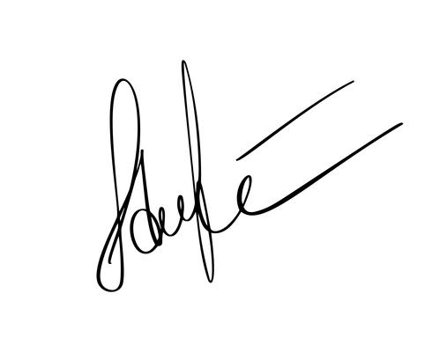
Name & Signature of Inspector


6
EXAMINATION REPORT
EQUIPMENT PARTS |  | S | NS | NA | SE | REMARKS
Document verification
1. | Previous inspection report | ☐ | ☐ | ☑ | ☐
2. | Manufacturer technical specification / conformity report | ☐ | ☐ | ☑ | ☐
Component
3. | Marking of SWL @ angle and ID No. | ☐ | ☐ | ☑ | ☐
4. | Chain sling condition  (wear: 8% ; elongation due to wear: 5% ; elongation due to stretch: 0%)(pitch: 3xdia) | ☐ | ☐ | ☑ | ☐
5. | Erosion or corrosion condition | ☐ | ☐ | ☑ | ☐
6. | General structure (bend, twist, stretch, Cuts, nicks, gouges, cracks, excessive corrosion, heat discolorations, or any other defects in chain etc.) | ☐ | ☐ | ☑ | ☐
7. | Welding joint | ☐ | ☐ | ☑ | ☐
Fittings
8. | Master link | ☐ | ☐ | ☑ | ☐
9. | Sub link | ☐ | ☐ | ☑ | ☐
10. | Coupling | ☐ | ☐ | ☑ | ☐
11. | Clutches | ☐ | ☐ | ☑ | ☐
12. | All components are same grade | ☐ | ☐ | ☑ | ☐
13. | Hook condition  (wear: 10% ; throat opening:15% ; twist: 10°) | ☐ | ☐ | ☑ | ☐
14. | Safety Latch | ☐ | ☐ | ☑ | ☐

S-Satisfactory, NS-Not Satisfactory, NA-Not Applicable, SE-Serviceable Finding Critical Finding

Finding: | Critical Finding: | Other Remarks:
Target Date of Closure: | Target Date of Closure: | Other Remarks:

PHOTOS OF INSPECTED CHAIN SLING

