This equipment certificate complies with the requirements of Emirates International Accreditation Centre for inspection bodies working in the field of Lifting Equipment and Lifting Accessories (EIAC-RQ-IB-002), reference standard LOLER 1998, BS ISO 22915-1:2016, BS ISO 22915-1:2008 Part 2 & 8: 2008, ISO 2331:1974, BS 5639-1:1978 and Manufacturer’s Specification.
Owner Name: Mr. Gaikwad
Office Address: P.O Box - 34601,
RAKIA FZ, RAK,
United Arab Emirates.
Equipment Location: Jebel Ali

INSPECTION DETAILS
Date of Inspection: |  | 13-11-2025 |  |  |  | Expiry Date: |  | FAILED
Inspection Type: THOROUGH
Previous Inspection Report: |  |  |  |  |  | Last Proof Load Test: |  | 13-11-2025
Test Method |  | CSI-24 |  |  |  | Calibrated Test Equipment: |  | vhj
 |  |  |  |  |  | Client Test Equipment: |  | gg
EQUIPMENT INSPECTION
Equipment Description: |  |  | gj
ID & Serial No.: |  |  | hh |  |  | LMI Type: |  | uu
Model: |  |  | hj |  |  | Max Boom Length: |  | g
Equipment Type: |  |  | v |  |  | Max Mast Tilt: |  | v
Equipment Manufacturer: |  |  | h |  |  | Unladen Weight: |  | h
Production Year: |  |  | 13-11-2025 |  |  | Max. Height of Lifting |  | h
Registration Number: |  |  | u |  |  | Rated Capacity |  | v
Fork Length: |  |  | h
Test Details | Boom Length  (Meters) |  |  | Radius  (Meters) | Fork Lifting Height  (mm) |  | Load Center  (mm) |  | Safe Working Load  (Tonnes)
Lift Capacity on Tires | h |  |  | b |   b |  | b |  | h
Lift Capacity on Stabilizer | h |  |  | j | f |  | g |  | h
SAFE WORKING LOAD AS PER LOAD CHART
- Is this the first examination after installation or assembly at a new location? ☑ Yes ☐ No
- If the answer to the above question is Yes, then has the equipment been installed correctly? ☐ Yes ☑ No
- Was the inspection carried out in accordance out in accordance with an examination scheme? ☐ Yes ☑ No

This is to certify that the above item/s described in this certificate was tested and particulars are correct.

CSSC has inventoried, inspected, verified and tested above mentioned equipment in accordance with the reference standards cited herein and consistent with CSSC policies and procedure. We certify this above mentioned equipment is UNSAFE TO USE, condition prevails at the time of this inspection.

All the information obtained /gathered during the inspection shall be preserved as confidential.
This inspection has been carried out as per local order no. : 2/2010;
This inspection certificate / report shall not be reproduced except in full without the approval of Claymore and the Client.

Inspected By: Katrina

Name & Signature of Inspector:


EXAMINATION REPORT
EQUIPMENT PARTS |  | S | NS | NA | SE | REMARKS
Document verification
1 | Previous inspection report | ☑ | ☐ | ☐ | ☐
2 | Maintenance log sheet | ☑ | ☐ | ☐ | ☐
3 | Mfg. Manual & technical instruction | ☑ | ☐ | ☐ | ☐
4 | Operator license and Competency Certificate | ☑ | ☐ | ☐ | ☐
5 | NDT Certificate | ☑ | ☐ | ☐ | ☐
6 | Torque Report | ☑ | ☐ | ☐ | ☐
 | Information
5 | Marking & identification of SWL & serial number or ID | ☑ | ☐ | ☐ | ☐
6 | Load Chart | ☑ | ☐ | ☐ | ☐
 | Control
7 | Steering Mechanism | ☑ | ☐ | ☐ | ☐
8 | Marking & identification on lever control | ☑ | ☐ | ☐ | ☐
9 | Hand Brake | ☑ | ☐ | ☐ | ☐
10 | Foot Brake | ☑ | ☐ | ☐ | ☐
11 | Tires condition& pressure level | ☑ | ☐ | ☐ | ☐
12 | Engine condition & oil level | ☑ | ☐ | ☐ | ☐
13 | Radiator condition& water level | ☑ | ☐ | ☐ | ☐
 | Boom
14 | Boom condition & alignment | ☑ | ☐ | ☐ | ☐
15 | Boom extract & retract | ☑ | ☐ | ☐ | ☐
16 | Boom cylinder | ☑ | ☐ | ☐ | ☐
17 | Overload indicator | ☑ | ☐ | ☐ | ☐
 | Mast & Fork
18 | Forks condition& its angle (wear – 10%; angle - +/-3°; fork tips height difference – 3% of blade length; straightness – 0.5% of blade/shank length) | ☑ | ☐ | ☐ | ☐
19 | Forks extension, if any (plus, 50% of the original fork length) | ☑ | ☐ | ☐ | ☐
20 | Hydraulic system | ☑ | ☐ | ☐ | ☐
21 | Chains condition & elongation (wear – 5%; elongation – 3% measured at 20 pitches) | ☑ | ☐ | ☐ | ☐
22 | Rollers | ☑ | ☐ | ☐ | ☐
23 | Pipe fittings & condition | ☑ | ☐ | ☐ | ☐
24 | Bolts and nuts fittings | ☑ | ☐ | ☐ | ☐
25 | Cylinders condition (main and auxiliary) | ☑ | ☐ | ☐ | ☐
26 | Guide frames | ☑ | ☐ | ☐ | ☐
27 | Mast condition (free from crack and deformation) | ☑ | ☐ | ☐ | ☐
28 | Mast alignment along with the fork alignment | ☑ | ☐ | ☐ | ☐
 | Electrical system
29 | Reverse Alarm Indication | ☑ | ☐ | ☐ | ☐
30 | Revolving Beacon | ☑ | ☐ | ☐ | ☐
21 | Lights Indication-Head, Brake, Reverse | ☑ | ☐ | ☐ | ☐
32 | Horn / buzzer | ☑ | ☐ | ☐ | ☐
33 | General electrical condition | ☑ | ☐ | ☐ | ☐
 | Cabin
34 | Roof condition | ☑ | ☐ | ☐ | ☐
35 | Seat condition | ☑ | ☐ | ☐ | ☐
36 | Seat belt condition | ☑ | ☐ | ☐ | ☐
37 | Clear load chart | ☑ | ☐ | ☐ | ☐
 | Other Accessories
38 | Fire extinguisher | ☑ | ☐ | ☐ | ☐
39 | Warning signs | ☑ | ☐ | ☐ | ☐
40 | Maintenance | ☑ | ☐ | ☐ | ☐
41 | Counter weight | ☑ | ☐ | ☐ | ☐
42 | Side mirrors | ☑ | ☐ | ☐ | ☐
 | Load test
43 | Overload system | ☑ | ☐ | ☐ | ☐
44 | Stability (100 %) | ☑ | ☐ | ☐ | ☐

S-Satisfactory, NS-Not Satisfactory, NA-Not Applicable, SE-Serviceable Finding Critical Finding

Finding: | Critical Finding: | Other Remarks:
Target Date of Closure: | Target Date of Closure: | Other Remarks:

PHOTOS OF INSPECTED FORKLIFT

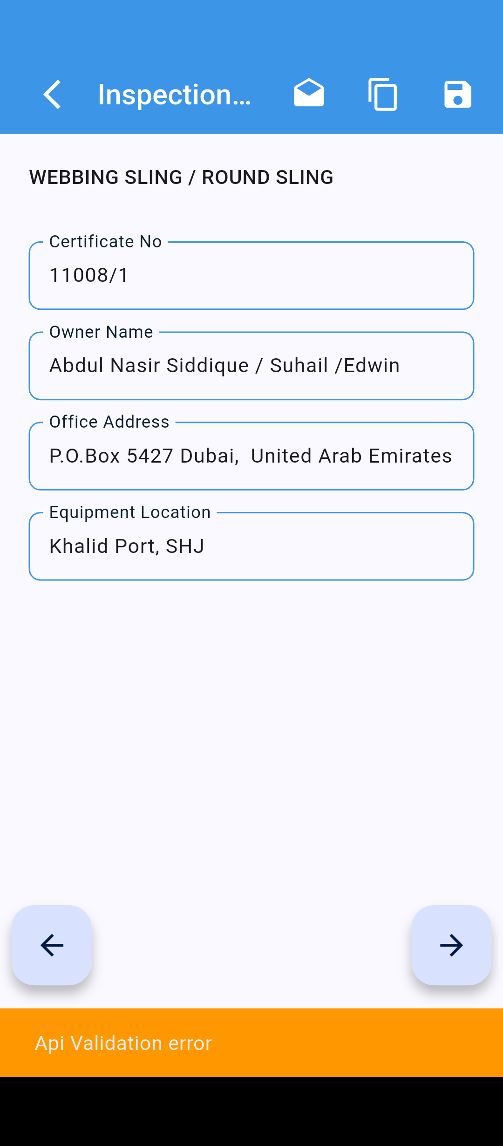 | 