
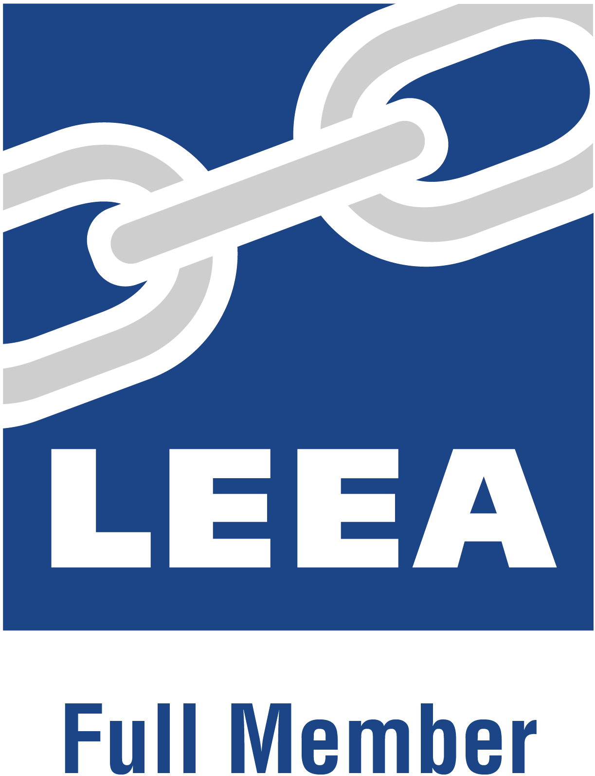
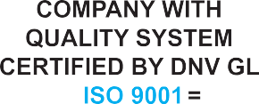

PRELIMINARY GENERAL RISK ASSESSMENT CHECK LIST
Client | AL FAYHA ALUMINIUM
Location | Deira
Inspector | Elizabeth Soriano
Work order / File No.: | 10974/0001  Date: 07-11-2025
Location Type |  | Risk |  | Description | Risk level
 |  | Yes/No |  | Description | High | Medium | Low
Construction Site |  | No |  |  | ☐ | ☐ | ☐
Industrial Site |  | No |  |  | ☐ | ☐ | ☐
Commercial Site |  | No |  |  | ☐ | ☐ | ☐
Hotel |  | No |  |  | ☐ | ☐ | ☐
Refinery |  | No |  |  | ☐ | ☐ | ☐
Training and Competencies
1 Formal safety induction process followed and  documented for employees? |  | No |  |  | ☐ | ☐ | ☐
2 Employees will be assessed and conducted their skills  before they commence work or perform a new task? |  | No |  |  | ☐ | ☐ | ☐
3 Emergency procedures |  | No |  |  | ☐ | ☐ | ☐
4 Inspector carries checklist & test method? |  | No |  |  | ☐ | ☐ | ☐
PPE
1 Cover all (Ordinary) |  | No |  |  | ☐ | ☐ | ☐
2 Cover all (Fire Proof) |  | No |  |  | ☐ | ☐ | ☐
3 Helmet |  | No |  |  | ☐ | ☐ | ☐
4 Safety Shoes |  | No |  |  | ☐ | ☐ | ☐
5 Safety Boots |  | No |  |  | ☐ | ☐ | ☐
6 Gloves |  | No |  |  | ☐ | ☐ | ☐
7 Goggles |  | No |  |  | ☐ | ☐ | ☐
8 Face Mask protection |  | No |  |  | ☐ | ☐ | ☐
9 Hearing protection |  | No |  |  | ☐ | ☐ | ☐
10 Harness belt with shock absorber lanyard |  | No |  |  | ☐ | ☐ | ☐
11 Life jacket |  | No |  |  | ☐ | ☐ | ☐
12 Radium Vest |  | No |  |  | ☐ | ☐ | ☐
13 Flashing Light or Reflector |  | No |  |  | ☐ | ☐ | ☐
14 Dust Mask Protection |  | No |  |  | ☐ | ☐ | ☐
At Equipment
1 Falling Hazard |  | No |  |  | ☐ | ☐ | ☐
2 Access Hazard |  | No |  |  | ☐ | ☐ | ☐
3 Slippery Hazard |  | No |  |  | ☐ | ☐ | ☐
4 Electrical Hazard |  | No |  |  | ☐ | ☐ | ☐
5 Moving / Rotating / Slewing Parts Hazard |  | No |  |  | ☐ | ☐ | ☐
6 Temperature Hazard |  | No |  |  | ☐ | ☐ | ☐
7 Pressure Hazard |  | No |  |  | ☐ | ☐ | ☐
8 Travelling Hazard |  | No |  |  | ☐ | ☐ | ☐
9 Tipping Load Hazard |  | No |  |  | ☐ | ☐ | ☐
Public Protection
1 Barricade protection |  | No |  |  | ☐ | ☐ | ☐
2 Sign boards |  | No |  |  | ☐ | ☐ | ☐
3 Guidance to public |  | No |  |  | ☐ | ☐ | ☐
Inspector  Name : Elizabeth Soriano |  |  |  | Clients  Name : AL FAYHA ALUMINIUM
Date : 07-11-2025 |  |  |  | Date : 07-11-2025

