





Job Order No : 11066 |  |  | Purchase Order No : LAM-00535431 |  |  | CSSC Report No : 00025
Date of Inspection | Time Arrived | Time Left | Site Hour | Travel Hours | Total Time | Comment if required
13-11-2025 | 11:46:22 | 11:52:55 | 00:06:33 |  | 00:06:33

Customer Data:
Customer Name: LAMPRELL ENERGY LTD. Contact No: NA
Company Name & Address: P. O. Box - 42149,
Sharjah,
United Arab Emirates.
Equipment Location: Hamriyah

Equipment Description:

Scope of Work:
Virtual Test ☐ Functional Test ☑ Load Test ☐ Witness ☑ Verification ☑
Document required:
Inspector carry the checklist: | Yes ☑ No ☐ |  | Inspection carry Test method: | Yes ☑ No ☐
Inspection carry filled Risk assessment form: | Yes ☐ No ☑
Customer acceptance certificate:
The above work has been completed/progressed: I have read & confirm this report & time sheet & certify the work has been done to my satisfaction.
Travelling time, expense & mileage will be charged extra.
Inspector Name: Mohan |  | Client Name: LAMPRELL ENERGY LTD.
  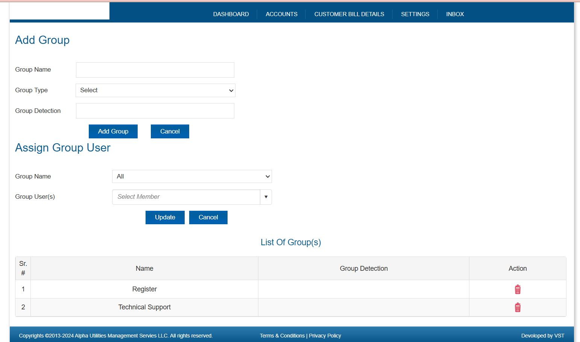
  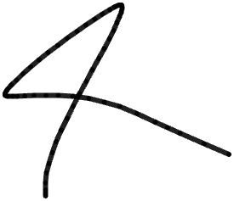
Sign & date: 13-11-2025 |  | Sign & date: 13-11-2025

