Employee Test API Document

Company GET Endpoint:
The Company GET endpoint allows you to retrieve company information.
Endpoint:
To retrieve company id and name, simply call the endpoint without any additional parameters.
Endpoint:



Response:
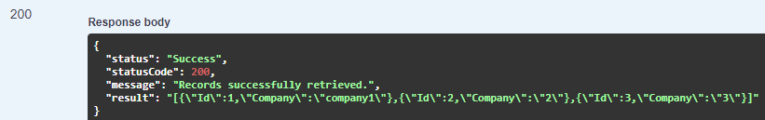

The Login Endpoint:
The Login Endpoint API allows users to authenticate and obtain a session token for accessing restricted resources.
Endpoint:
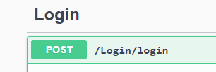
This endpoint is used for user authentication.

Request Parameters:
Parameter | Type | Description
username | string | The username of the user
password | string | The password of the user
database | string | The database of the user

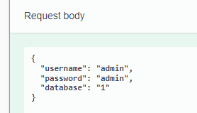

Response:
200 OK - Successful authentication returns a success message with session tokens.

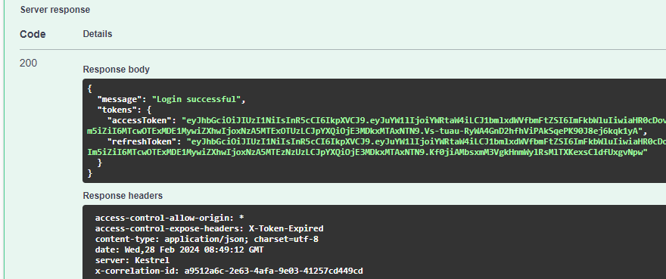

404 Not Found – Failure authentication returns a user not found message.
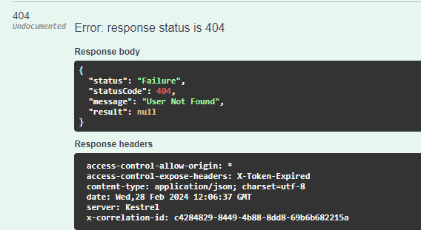
City/Country/Department:

POST Endpoint:

Request Body

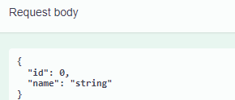

"id": Represents the unique identifier of the city/country/department.
If id is set to 0, it indicates that a new city/country/department should be created.
If id is a non-zero integer, it represents the city/country/department to be updated.
"name": Represents the name of the city/country/department.
This field is required and cannot be an empty string.
The value should be a string containing the name of the city/country/department to be created or updated.

GET Endpoint with search:
This GET endpoint allows you to retrieve all city/country/department where the value in the Name column starts with the value provided in the search parameter.
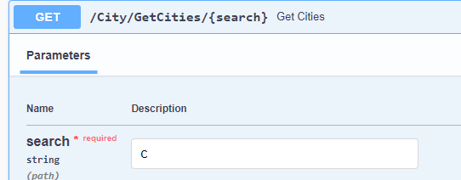
Success Response:
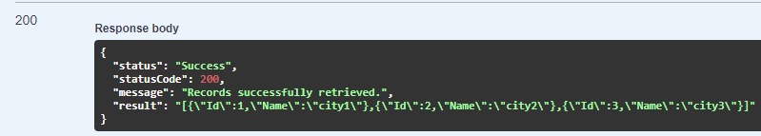
Failure Response:
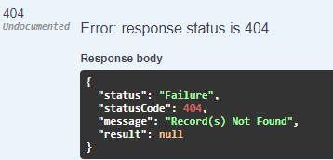

GET Endpoint with Id:
This GET endpoint allows you to retrieve a specific city/country/department by providing their Id.
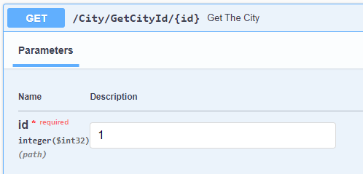
Success Response:
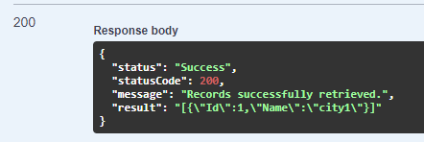

Employee POST Endpoint:
The Employee POST endpoint allows you to create or update employee record.
Endpoint:
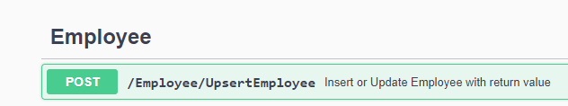

Request Body:
Field | Type | Description
Name | string | The name of the employee. Required, cannot be empty.
Dob | string (Date) | The date of birth of the employee (format: YYYY-MM-DD).
Address | string | The address of the employee. Required.
CityId | int | The ID of the city where the employee resides.
CountryId | int | The ID of the country where the employee resides.
PinCode | int | The PIN code of the employee's address.
DateofJoining | string (Date) | The date when the employee joined (format: YYYY-MM-DD).
DepartmentId | int | The ID of the department the employee belongs to.
PreviousSalary | double | The previous salary of the employee.
CurrentSalary | double | The current salary of the employee.
The request body should be a JSON object representing the employee details to be created.

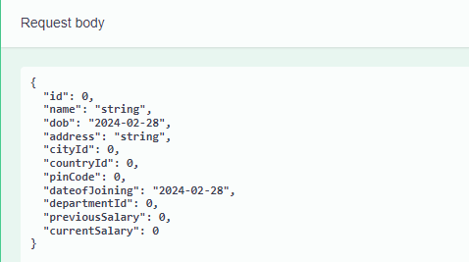

Response:
201 Created - Employee record successfully created. Returns the created employee object with its Id.
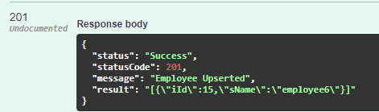
409 Conflict – Returns a conflict message if the employee already exists.
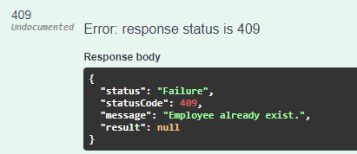

Employee GET Endpoint:
The Employee GET endpoint allows you to retrieve employee information. You can retrieve information for a specific employee by providing their Id, or retrieve information for all employees
Endpoint without Parameter:
To retrieve information for all employees, simply call the endpoint without any additional parameters.
Endpoint:

Endpoint with ID:
To retrieve information for a specific employee, provide the employee's ID as a parameter.
Endpoint:
Response:
200 OK - Records successfully retrieved. Returns JSON serialized employee details.
404 Not Found – Returns failure message records not found.

